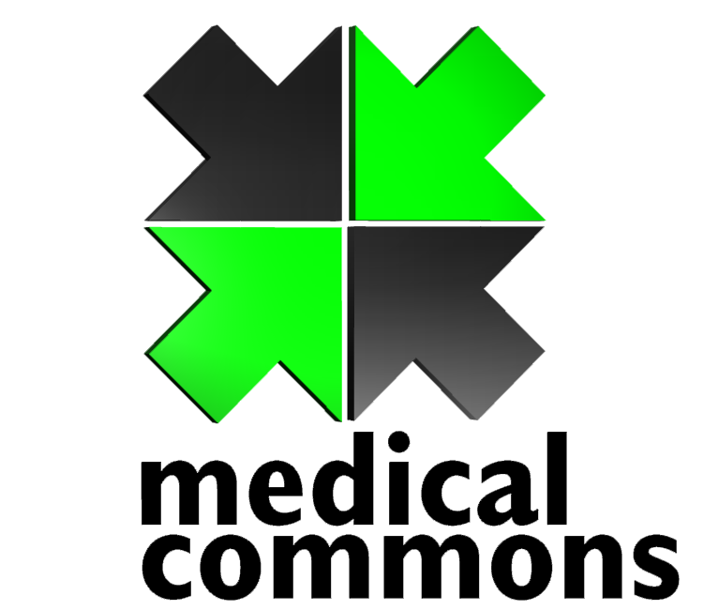

To view this please PRINT it. The on screen colors are lurid and way off. This, of course is just a starting point.

I have checked out the “medical commons” trademark on the .gov TESS system. It is interesting. There are 5800 trademarks with the word ‘medical’ , 737 trademarks with the word ‘commons’ and 0 trademarks for ‘medical commons’. At least from a trademark point of view ‘medical commons’ is a very good choice.

If I don’t hear from you to the contrary, I will tell Three Feet (branding company) about the change. If they don’t have a problem with it, then it will be our new name.

Hugh

